This is a simple tutorial to teach you how to use these codes to extract shell features and load these features for classification. Before you run the program, please check the software requirements:

* MATLAB 2018b
* Microsoft Excel

1. Color feature

In order to extract color feature, you need two matlab files: auto_color.im and color_feature.m respectively. Please put all shell images and two matlab files in a folder of the same path (Figure 1), then open auto_color.m in matlab, run it immediately. All extracted color feature data will be saved in an Excel file.

We also provide an example in color_feature_example.zip file, containing .m files and 160 shell images, you can attempt to run it as long as you want.

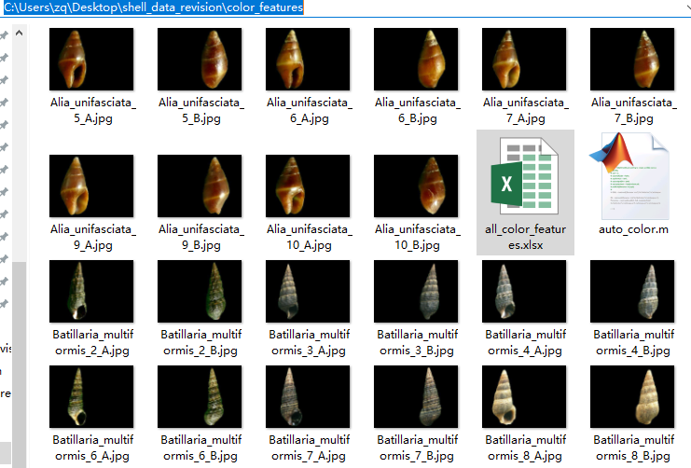

Figure 1. Color feature extraction. Put two .m files and all shell images in the same path folder.

1. Shape feature

In order to extract shape feature, you need two matlab files: auto_shape.im and shape_extract.m respectively. Please put all shell images and two matlab files in a folder of the same path, then open auto_shape.im in matlab, run it immediately. All extracted shape feature data will be saved in an Excel file.

We also provide an example in shape_feature_example.zip file, containing .m files and 160 shell images, you can attempt to run it as long as you want.

1. Texture feature

In order to extract texture feature, you need two matlab files: auto_texture.im and texture_extract.m respectively. Please put all shell images and two matlab files in a folder of the same path, then open auto_texture.im in matlab, run it immediately. All extracted texture feature data will be saved in an Excel file.

We also provide an example in texture_feature_example.zip file, containing .m files and 80 shell images, you can attempt to run it as long as you want.